**Precision Agriculture for Crop Management System   
Nur Aliah Binti Hasshim  
S2031689**

**Introduction**  
  
Agriculture is defined as the science of farming which includes cultivation of soil to grow crops and raising livestock to be distributed to market for human’s usage. While it is usually associated with food, it actually goes beyond by providing other raw materials such as wools, palm oil, and wood that is essential in manufacturing sectors. In Malaysia, it remains as an important sector, providing 16% of population for employment and contribute 12% in GDP. In 1999, Malaysia is the world’s largest producers of palm oil.  
  
As Data Science can be applied to problems across the industries, agriculture is part of the industry benefitting from it. By using the data collected in agriculture, farmers can manage crop diseases and pest by collecting data using Internet of Things (IoT) sensors to detect the insects and its kind on crops and predict the amount of pest needed to be used to overcome the problems. Besides, farmers can have yield prediction to have an overview of what is coming few months in advance and make necessary decision if needed. These applications will benefit farmers manage their farms productively, efficiently and reduces cost incurred.

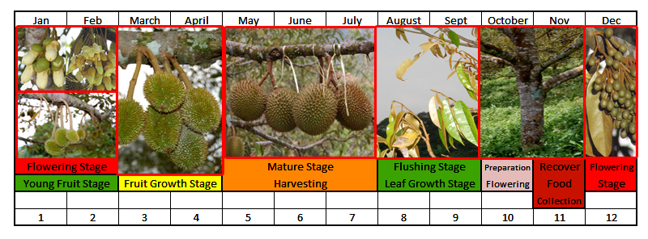**Data Product and Dataset**  
  
Precision Agriculture for Crop Management System is the data product with the objective to make efficient production, increase profitability and data-driven decision making. By using images of crops specifically plants, this system will be trained by prediction model using machine learning algorithm as in Figure 1 to count and classify growth, and condition of plants in the farm.   
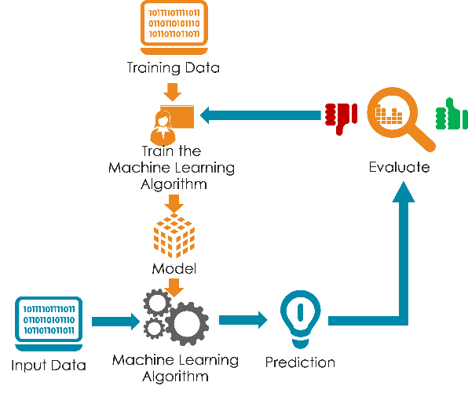  
Figure 1: Process of building a prediction model using machine learning. Images from https://medium.com/@tuhlens/data-science-a-skill-in-demand-77da07e16e70  
  
Taking durian farm as an example, the algorithm will be fed with training data in images format of durian trees and fruits as in Figure 2 and Figure 3 at different stages of growth to get the algorithm to recognize and differentiate durian trees from other trees.  
Figure 2: Different growth stages of Durian Fruit for classification. Image from <http://durianrasasedap.blogspot.com/2014/04/durian-crop-production-cycle-and.html>  
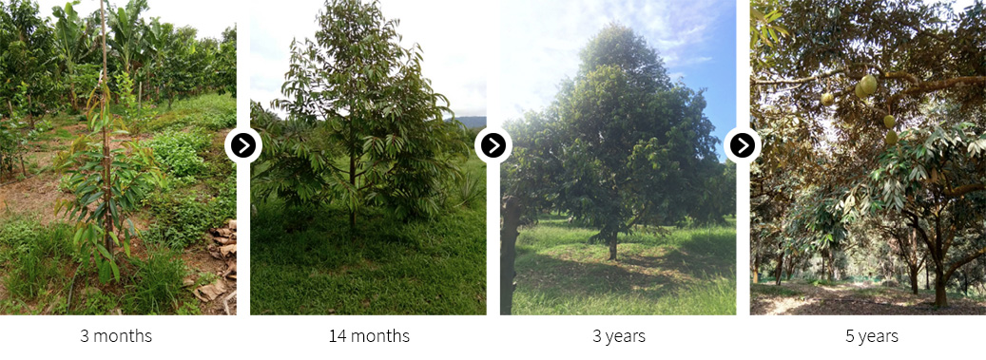Figure 3: Different growth stages of Durian Tree for classification. Image from https://nutmon.org/durian-plantation/  
  
Once the algorithm manages to identify and differentiate the growth stages of both the fruit and the tree, drone with camera will be used as the input data collection device where it will capture images and record videos across the farm. Based on the data collected, it will straight away calculate the number of durian trees in the farm, and number of durian trees in each stages of growth. By identifying the stages of growth, the system can predict how many trees will start to bear fruits in the upcoming season. Looking into the details, the system can also predict how much fruits in each individual trees. Furthermore, by using the drone, it can identify the gaps between the trees and lead to farmer make replanting decision.  
  
Since durian is a seasonal fruit, this system can give an alert when the trees have started to enter the fruit growth stages and identify any abnormalities among the trees such as withering trees that stopped producing fruits. This will give insights on how much fruits can be expected and predicted to be produced in the season and give an overview of how much sales can be earned when the fruits are harvested.

A drone can fly across the farm in minutes to hours depending on the size. The farmers will get to reduce cost where less human is needed to collect data and monitor the farm regularly especially if the farm is big, faster decision making as the time taken to get the data has reduced and improve efficiency in the farm.   
  
Datasets needed in this data product is as stated above where for the training data, different growth stages of the trees and fruits images are needed. It can be historical images from past season, images from other farms or images from online library such as Eden Library. Variety images can will make the system predict the outcome better and more accurate. As for the input data, it is the one captured using the camera attached to the drone in the form of images and videos.

**References**1)https://www.nationalgeographic.org/encyclopedia/agriculture/#:~:text=Agriculture%20is%20the%20art%20and,the%20world's%20food%20and%20fabrics.  
  
2) https://theimportantsite.com/10-reasons-why-agriculture-is-important/  
  
3) https://impoff.com/importance-of-agriculture/  
  
4) https://www.nationsencyclopedia.com/economies/Asia-and-the-Pacific/Malaysia-AGRICULTURE.html  
  
5) https://www.precisionhawk.com/blog/media/topic/understanding-your-aerial-data-plant-counting